Physics Quiz User Manual

**1. About the software**

**2. Setting up JRE**

**3. About the web server**

**4. Starting up the software**

**5.Using the quiz**

By Nathan Akrill

Guide to setting up and using the Physics Quiz program

1. *About the software*

The Physics Quiz package is consisted of 2 pieces of software.

The first is a web server application that hosts a database with the question for the quiz.

The second is the PhysicsQuiz.jar application that runs the quiz, and is the software that you, the user will be interacting with the most. It has been developed using Java Version 7.

The quiz is a very simple piece of software, such that it will run on any computer, if the latest version of Java Runtime Environment is installed.

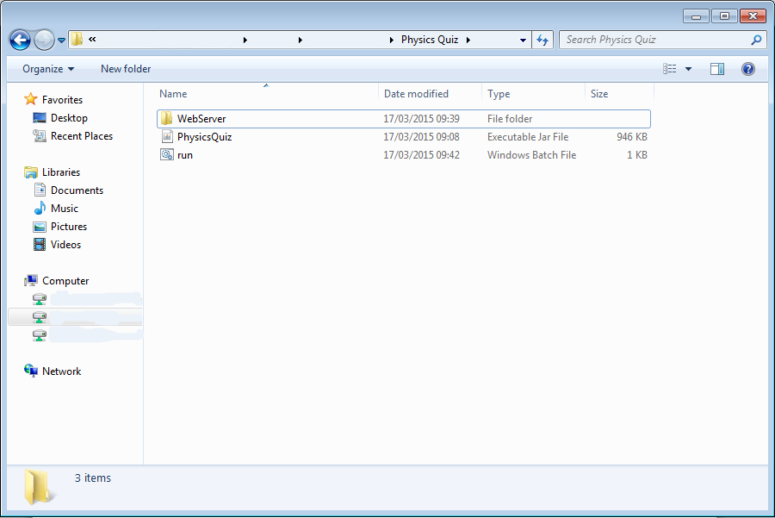

*The file tree for the package*

To run the Physics Quiz application, your computer needs to have the latest version of JRE installed.

1. Go to <http://java.com/en/download/>
2. Click on download. If prompted, click “save”.
3. When the download is finished, click “run”.
4. If prompted, click “run” again.
5. Go through the install wizard.
6. JRE is now installed.

*2. Click “save”*

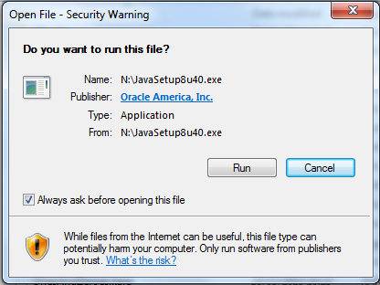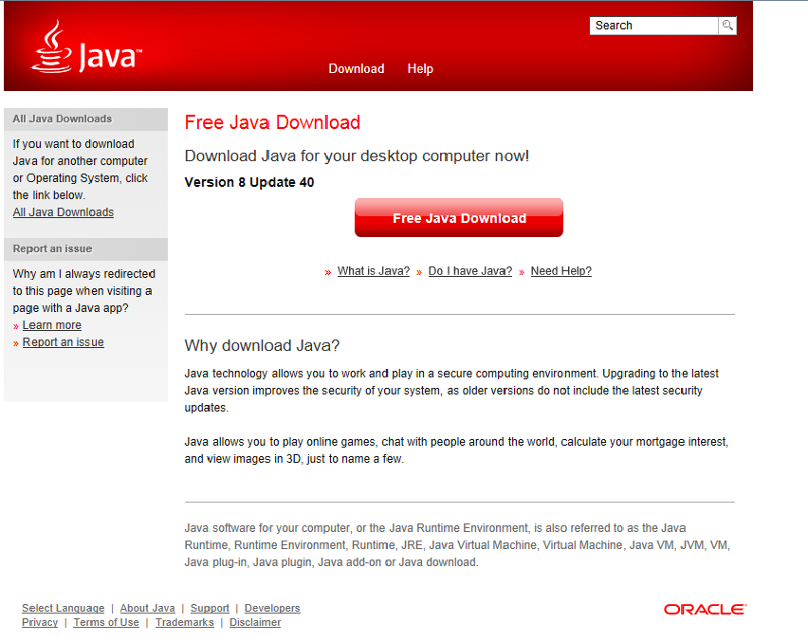

*3. Click “run”*

*1. The JRE Download page*

*2. Setting up JRE (Java Runtime Environment)*

*4. Click “run” again*

The web server application is called UsbWebServer and is developed by . It hosts the database with the questions on your computer. When run, a blue window will appear. If it is functioning properly, two green ticks will appear. You can minimise this window and ignore it when you are using the quiz.

*3. About the Web Server*

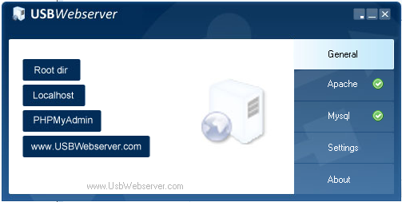

*The USBWebServer window*

Before you can get started, you need to extract the “Physics Quiz.zip”. To do this, right click, and select “Extract All”. You can delete the .zip once this is done.

To start up the software, click the “run.bat” file inside the folder. This will open up a command prompt while running the web server. Once the web server is running, and displays the two green ticks, you can press enter to continue. The Physics Quiz window will now appear, and you can follow the steps on the next page to use the quiz.

*4. Starting up the software*

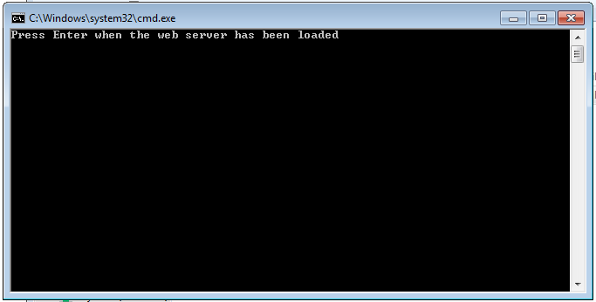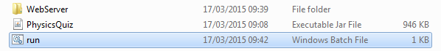

*The CMD window*

*Click on “run”*

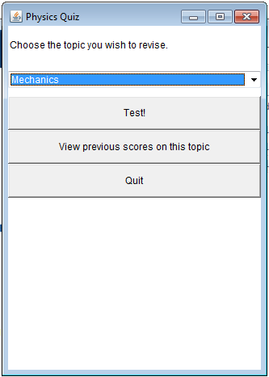

The first window you will see is the menu window. This is where you choose the topic you wish to be quizzed on.

*5. Using the quiz*

Use the drop-down menu to select a topic and click “Test!” to start the quiz. In the quiz, you will come across 2 types of question, multiple choice and calculation.

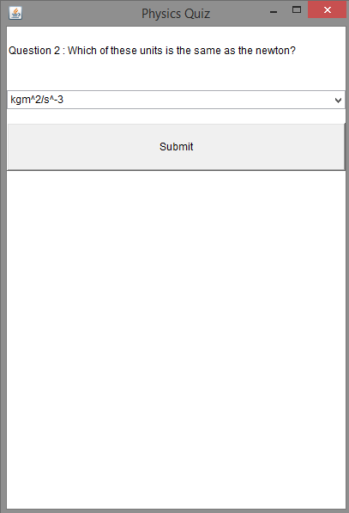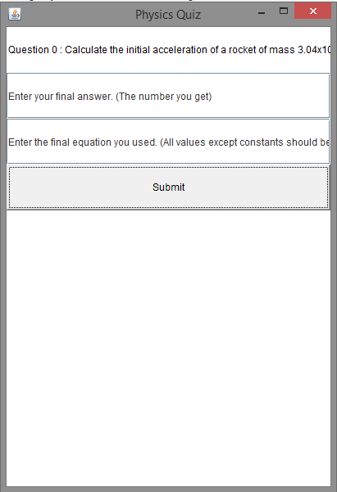On a multiple choice question, select your answer from the drop-down menu and click “Submit” to move on to the next question. On a calculation question, enter in the final number you get, and the equation you used to get that number. If you used more than one equation, enter in the last equation you used. Make sure all equations are written in full using capital letters. E.g. Force = Mass x Acceleration

*A Multiple Choice Question*

*A Calculation Question*

After 10 questions, you will see the feedback screen. This shows you your final score (out of 10) and lists all the questions you got wrong. Here you can enter your name to have the score saved to a text file in the directory that the program is stored in. This can be used to review your progress, and it is useful to compare your scores on different topics to find those that you need to revise more than others.

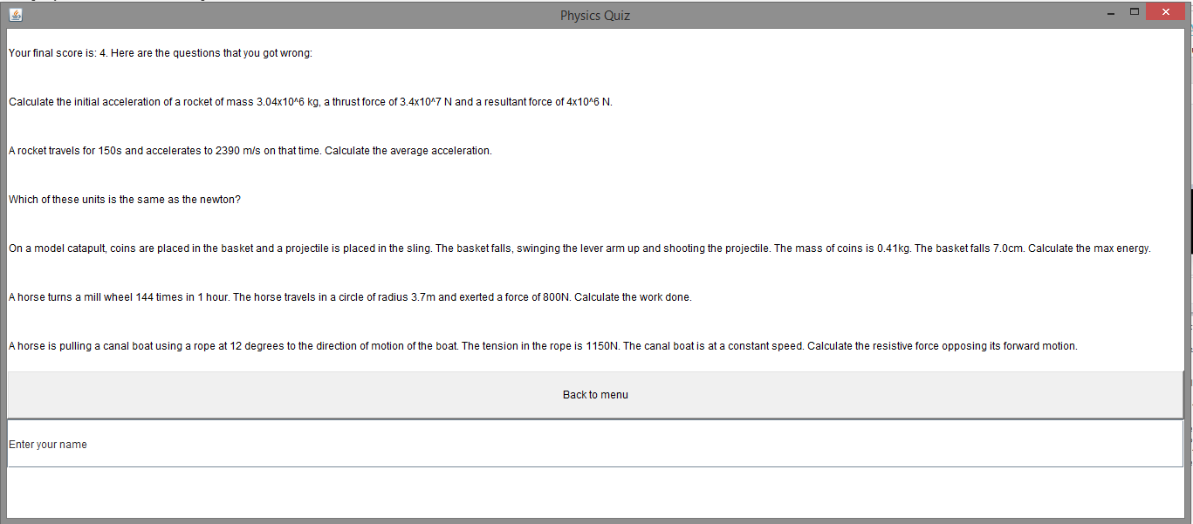

*The feedback screen*